Occupational Health and Safety issues for the Australian Electrical industry

Presentation to 2014 FAPECA Conference

Suresh Manickam
May 2014

The Australian Situation
Safe Work Australia was established by the Safe Work Australia Act 2008 with primary responsibility to lead the development of policy to improve work health and safety and workers’ compensation arrangements across Australia. It performs its functions in accordance with strategic and operational plans agreed annually by the Select Council on Workplace Relations.
Safe Work Australia began operating as an independent Australian Government statutory agency on 1 November 2009. It is jointly funded by the Commonwealth, state and territory governments through an Intergovernmental Agreement.
As a national policy body Safe Work Australia does not regulate work health and safety laws. The Commonwealth, states and territories retain responsibility for regulating and enforcing work health and safety laws in their jurisdiction.
Safe Work Australia is a tripartite body with the following members:
- an independent chair
- members representing the Commonwealth and each state and territory
- members representing the interests of workers
- members representing the interests of employers, and
- the Chief Executive Officer.
The key functions of Safe Work Australia as set out in the Safe Work Australia Act 2008 are to:
- develop national policy relating to OHS and workers’ compensation
- prepare a model Act and model regulations relating to OHS and, if necessary, revise them:
  - for approval by WRMC, and
  - for adoption as laws of the Commonwealth, each of the States and each of the Territories
- prepare model codes of practice relating to OHS and, if necessary, revise them:
  - for approval by WRMC, and
  - for adoption as codes of practice of the Commonwealth, each of the States and each of the territories and made under laws of those jurisdictions that adopt the approved model OHS legislation
- prepare other material relating to OHS and, if necessary, revise that material
- develop a policy, for approval by WRMC, dealing with the compliance and enforcement of the Australian laws that adopt the approved model OHS legislation, to ensure that a nationally consistent approach is taken to compliance and enforcement
- monitor the adoption by the Commonwealth, states and territories of:
  - the approved model OHS legislation as a law of those jurisdictions
  - the approved model OHS codes of practice as codes of practice of those jurisdictions, and
  - the approved OHS compliance and enforcement policy as a policy of those jurisdictions
- collect, analyse and publish data or other information relating to OHS and workers’ compensation in order to inform the development or evaluation of policies in relation to those matters
- conduct and publish research relating to OHS and workers’ compensation in order to inform the development or evaluation of policies in relation to those matters
- revise and further develop the National OHS Strategy 2002-2012 released by WRMC on 24 May 2002, as amended from time to time
- develop and promote national strategies to raise awareness of OHS and workers’ compensation
- develop proposals relating to:
  - harmonising workers’ compensation arrangements across the Commonwealth, states and territories, and
  - workers’ compensation arrangements for employers with workers in more than one of those jurisdictions
- advise WRMC on matters relating to OHS or workers’ compensation
- liaise with other countries or international organisations on matters relating to OHS or workers’ compensation, and
- perform such other functions that are conferred on it by WRMC.
In accordance with the Intergovernmental Agreement for Regulatory and Operational Reform in Occupational Health and Safety, Safe Work Australia develops model Codes of Practice as part of the package of harmonised work health and safety laws. Model Codes of Practice are often based on jurisdictional codes in place at the time of development and are informed by public comment.
Codes of practice are practical guides to achieving the standards of health, safety and welfare required under the Work Health and Safety (WHS) Act and the WHS Regulations in a jurisdiction.
The following broad industry groups have been identified as national priorities for prevention activities:
- Agriculture
- Road transport
- Manufacturing
- Construction
- Accommodation and food services
- Public administration and safety
- Health care and social assistance.
In 2012, these industries were found to have high numbers and rates of injury and/or fatalities, or were by their nature hazardous. The national industry priorities focus attention and activities on identifying the cause of injury and illness and on working to find and implement solutions.
In order to focus attention on areas that require the greatest improvement, relevant sub sectors from within these broad industry groups will be chosen by jurisdictions during specified periods during the life of the Australian Strategy.
The agriculture and road freight transport industries will be the focus of efforts in all jurisdictions during the first five years of the Australian Strategy to reduce the high numbers of fatalities in these industries.
Information and resources are being developed for each priority industry.
The Australian Work Health and Safety Strategy 2012-2022 (the Australian Strategy) sets out seven action areas to achieve the vision and outcomes.
Information and resources are being developed for each Action Area:
- Healthy and safe by design
- Supply chains and networks
- Health and safety capabilities
- Leadership and culture
- Research and evaluation
- Government, and
- Responsive and effective regulatory framework
Strategic outcomes have been developed for each of the action areas to provide a focus for the development and implementation of specific activities. The action areas and their related strategic outcomes are set out in the table below.

Action Areas | Strategic Outcomes | Strategic outcomes achieved by
Healthy and safe by design | Hazards are eliminated or minimised by design | - Structures, plant and substances are designed to eliminate or minimise hazards and risks before they are introduced into the workplace.  - Work, work processes and systems of work are designed and managed to eliminate or minimise hazards and risks.
Supply chains and networks | Improved work health and safety through supply chains and networks | - Supply chain and network participants understand their cumulative impact and actively improve the health and safety of the supply chain.  - Commercial relationships within supply chains and networks are used to improve work health and safety.  - Industry leaders champion work health and safety in supply chains and networks.
Health and safety capabilities | Improved work health and safety capabilities | - Everyone in a workplace has the work health and safety capabilities they require.  - Those providing work health and safety education, training and advice have the appropriate capabilities.  - Inspectors and other staff of work health and safety regulators have the work health and safety capabilities to effectively perform their role.  - Work health and safety skills development is integrated effectively into relevant education and training programs.
Leadership and culture | Leaders in communities and organisations promote a positive culture for health and safety | - Communities and their leaders drive improved work health and safety.  - Organisational leaders foster a culture of consultation and collaboration which actively improves work health and safety.  - Health and safety is given priority in all work processes and decisions.
Research and evaluation | Evidence–informed policy, programs and practice | - Research and evaluation are targeted to provide the evidence to prioritise and progress areas of national interest.  - Australia has an effective research and evaluation infrastructure and capacity.  - Evidence is translated to assist practical application.  - The results of research and evaluation are disseminated and implemented.
Government | Governments improve work health and safety | - Work health and safety is actively considered in the development, implementation and evaluation of government policy.  - Governments use their investment and purchasing power to improve work health and safety.  - Governments exemplify good work health and safety.
Responsive and effective regulatory framework | The regulatory framework improves effectiveness by responding and adapting to changing circumstances | - Legislation, policies and regulatory practice are reviewed and monitored to ensure they are responsive and effective.  - Relationships between regulators and all who have a stake in work health and safety are effective, constructive, transparent and accountable.

Development of the Action Areas
These national Action Areas were chosen because:
- Prevention activities should be directed to where there is the greatest potential for reducing harm.
- Hazards and risks are most effectively controlled at the source.
- Prevention effort should focus on eliminating or minimising exposure to serious hazards and risks and progressively improving controls. If elimination is not practical then risks need to be minimised according to the hierarchy of control.
- Where a hazard exists but the level of risk is not certain, the risk should be assumed to be high and managed accordingly until the actual level of risk is known.
- Creating healthy and safe work requires that jobs and tasks be designed to accommodate the abilities, diversity and vulnerabilities of workers, including those returning to work following injury or illness.
- Continued improvement in work health and safety requires ongoing collaboration and cooperation between all parties.
- Workers have the right to be genuinely consulted in all matters relating to their work health and safety.
- Organisation leaders influence work health and safety through their management, education and procurement practices.
- Work health and safety improvements are best achieved when health and safety is supported by the organisation’s culture and embedded in its procedures and processes.
- The community and its leaders can influence attitudes and cultural norms.
- All parties with a role in work health and safety require appropriate knowledge and skills.
- Work health and safety policy and practice should be informed by evidence.
- Governments can strongly influence work health and safety.
- The regulatory framework needs to be flexible, responsive and adaptive to the changing nature of work and work circumstances.

State/territory Government regulation
It is the responsibility of the Commonwealth, states and territories to regulate and enforce work health and safety in their jurisdiction.
State/Territory work health and safety regulator are responsible for regulation, enforcement, information and advice on:
- Complying with work health and safety laws.
- Reporting a workplace incident.
- Renewing or applying for licences.
- Injury and workers’ compensation claims.
- Workers’ compensation insurance and premiums.
- Registration and notification of plant and plant designs.
- Health and safety representative training.
- Work health and safety training and assessment.

State and territory governments continue to work with Safe Work Australia to harmonise legislation that impacts on employers across Australia. Where major employers are involved or significant projects are worked on, an employer may need to deal with a number of agencies and legislation. This has lessened over time with only two states operating outside the harmonisation process, namely Western Australia and Victoria. There are different views on whether the states will come under the national process.

The overall Construction industry

The Construction industry employed 1.01 million people in 2011–12 (9% of the Australian workforce). Within this industry 73% of workers were classed as employees and were covered by workers’ compensation. Employers in this industry paid 2.3% of payroll in 2011–12 to provide workers’ compensation coverage for their employees.

Fatalities

Over the five years from 2007–08 to 2011–12, 211 Construction workers died from work-related injuries. The total number of deaths equates to 4.34 fatalities per 100 000 workers, which is nearly twice the national rate of 2.29.
- Falls from height accounted for 51 fatalities. Of these, 18 involved falls from buildings, 15 involved ladders and 8 involved scaffolding.
- Vehicle incident resulted in 34 fatalities. In 21 of the incidents the worker was in a car and 10 were in a truck.
- Being hit by moving objects and Being hit by falling objects accounted for 29 deaths each. More than half of the deaths caused by Being hit by moving objects involved road transport (16).

Serious Claims

The preliminary data for 2011–12 show there were 13 735 successful workers’ compensation claims for serious injury or illness in the Construction industry. Over the five years from 2007–08 to 2011–12, the Construction industry accounted for 11% of all serious workers’ compensation claims. On average there were 39 claims each day from employees who required one or more weeks off work because of work-related injury or disease.
Figure 1 shows that the incidence rate of serious claims in this industry has fallen 38% from 31.0 claims per 1000 employees in 2000–01 to 19.1 in 2010–11. However, this rate remains higher than the rate for all industries (12.7) and was the fifth highest of all industries in 2010–11.
Figure 1: Serious claims: Incidence rates by year

Between 2007–08 and 2011–12:

- Body stressing accounted for 34% of claims—more than half of these were due to muscular stress while handling a range of materials, tools and other equipment.
- Falls, trips and slips of a person accounted for 26% of claims and almost all of these involved Falls from height or Falls on same level.
- Being hit by moving objects accounted for a further 16% of claims—many of these involved being hit by falling or moving materials and equipment.

Serious claims by jurisdiction

Figure 2 shows the incidence rates of serious claims in the Construction industry by jurisdiction.
Over the period 2007–08 to 2010–11 all jurisdictions except Tasmania recorded decreases in incidence rates. The largest decreases were recorded by South Australia and the Northern Territory (both 31%) followed by Queensland (29%) and Western Australia (10%). Tasmania recorded a small increase (3%).

The preliminary data for 2011–12 show that incidence rates across Australia ranged from 12.0 claims per 1000 employees in the Northern Territory to 30.2 in the Australian Capital Territory.

Figure 2: Serious claims: Incidence rates by jurisdiction

Claims involving 12 or more weeks’ time lost by jurisdiction

Figure 3 shows the incidence rates of claims involving 12 or more weeks off work by jurisdiction. Preliminary data for 2011–12 show 30% of serious claims had compensation paid for 12 or more weeks off work.

Over the period 2007–08 to 2010–11 the Northern Territory recorded the largest decrease in incidence rates of long term claims (48%) followed by South Australia (28%). The Australian Capital Territory recorded a 36% increase in the incidence rate of long term claims.

The preliminary data for 2011–12 show that the Australian Capital Territory recorded the highest incidence rate with 9.3 long term claims per 1000 employees.

Figure 3: Claims involving 12 or more weeks off work: Incidence rates by jurisdiction

NECA training and other support arrangements

Given the extensive legislation operating across Australia and the serious fines involved for breaching the law, Workplace Health and Safety (WHS) issues are an important part of member servicing.
All chapters offer different but similar:
- Management plans
- Policies
- Forms
- Publications (including the “Safety Guide for Workers in the Data and Electrical and Communications and Electronic Security Industries – the Red Book)
Some chapters also offer:
- Provision of WHS practitioners on a fixed rate/predetermined hours contract or hourly rate
- Injury management and return to work systems
- Insurance arrangements

The types of services offered vary from selling a complete integrated online management system with a form of external certification, to providing adhoc WHS tools and providing manual hard copy updates. The lack of a national agreement on harmonisation and different legislation complicate national service delivery for the association. The type of service required by the member and their ability to pay is another factor in different service provisions.
All of the NECA Chapters have staff dedicated to providing WHS Services to members. Most staff have a Certificate III in Workplace Health and Safety which is a nationally recognised vocational qualification. NECA also provides services to its own group employment schemes with approximately 2,200 apprentices employed directly by NECA. It is an important approach as good WHS training and support reduce workers compensation insurance premiums and lessen the costs of apprentices for host employers.
The national marketing banner and program for NECA is NECASafe.

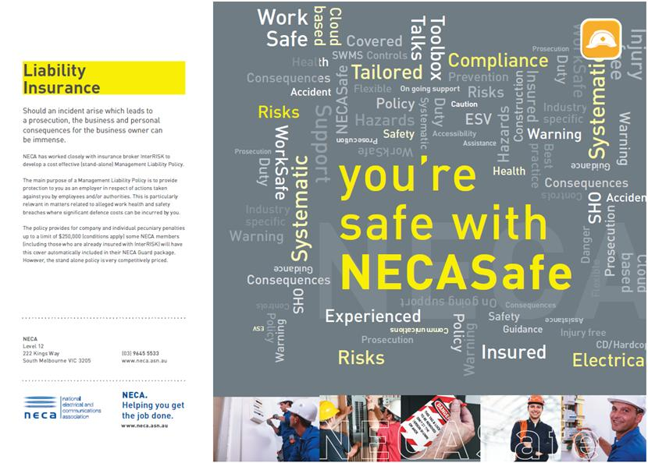

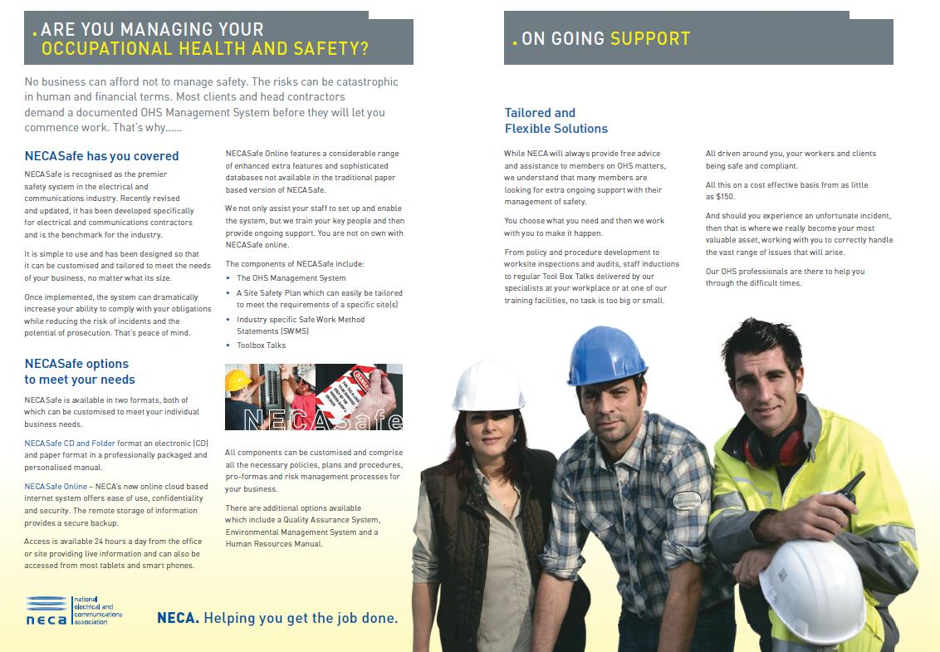

NECA also has extensive training for members. These courses are offered online or in a classroom setting and may take from three days to half hour to complete and include:
- NECA Managers and Supervisors OHS Course
- Working Safely at Heights
- Asbestos Safety and/or Awareness
- First Aid
- Red Book quiz,
- risk management
- manual handling
- workplace stress
- circuit testing
- working near power lines
- Heights safety Essentials
- Quality Management

*****

